How to Log in
- Open your Internet Browser (Internet Explorer, Firefox, etc).
- Type the following into the web address bar:
http://www.myschoolbuilding.com/sso/default.aspx?acctnum= insert account number

- If you are prompted to login after using this link, you will enter your organizational credentials here.
The Dude Says:
To create a shortcut to your desktop, find a blank area on this screen and right click on your mouse. You will have the option to create a shortcut or add to your favorites. Creating a shortcut will add an icon to your desktop. You can double click it the next time you want to sign in.

How to Submit a Request
- Make sure you are on the IT Request tab at the top of the screen.
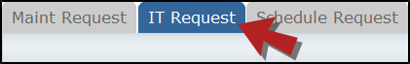
*Note: Any field marked with a red checkmark is a required field.
- Step 1: These fields will already be filled in with your contact information.
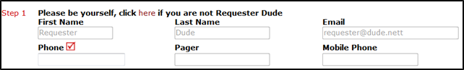
- Step 2: Click on the drop down arrow and highlight the Location where the work needs to be done. Do the same for Building (if available) and Area. Also, be sure to type in the area description or room number in the Area/Room Number field.
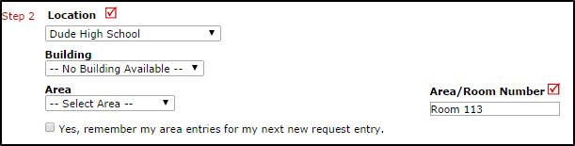
- Step 3: Select the Problem Type that best describes the request/issue you are reporting.
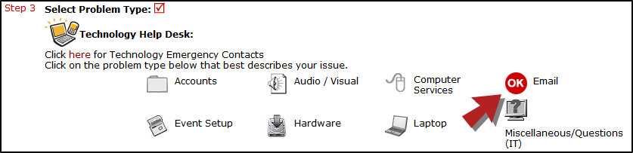
- Step 4: Type in a Description of the problem.
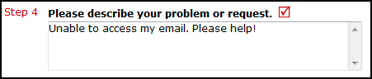
- Step 5: Depending on the technology problem type you selected in Step 3, there may be extra questions to answer here that will give more detail about your request. Fill out the Questionnaire and remember that any fields with a red checkmark beside it are required.
- Step 6: Enter a Tag Number if necessary for a specific piece of equipment that needs to be worked on.
- Step 7: Enter a Time Available, such as a planning period, when workers can come by.
- Step 8: Select a Purpose for the work if applicable.
- Step 9: Attach a file to the request if necessary (i.e. a picture of damage or screenshot).
- Step 10: Click the Submit button.
My Request Tab
You can view any requests that you have entered into the system by clicking on the My Requests tab. Hover your mouse over the Shortcuts link and click on My IT Requests. You will see a listing of any requests that you have entered into the system. You are also able to print out a listing of your requests by clicking on the printer icon.
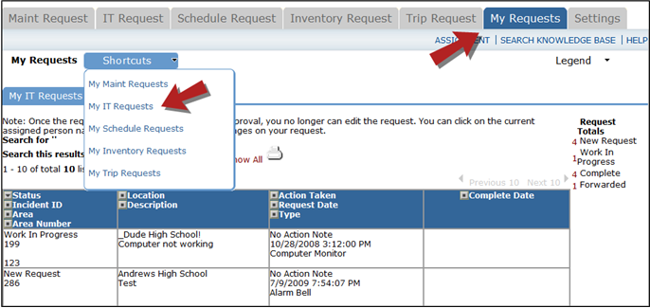
On the My Requests page you will see up-to-date information on your requests including the current status, incident ID number, and action taken notes. You can click on the number next to the status description in the Request Totals section to see all of your requests marked with that status. You can also search for any work order request by typing a key word into the Search box and clicking GO.

